DOCUMENT 22 — Memory & Spaced-Repetition System Spec
Visionary Internal · v1.0 · VATS Layer 6 as the retention moat

Six months of history makes switching unthinkable. The same memory that personalizes
is the memory the user can inspect, correct and erase — transparency is the moat's price.

1. Tiers & stores

Tier | Store | Contents | TTL
Short-term | Redis | session context (concepts, checks, mistakes) injected into every LLM call | 2h
Episodic | Qdrant (per-student namespace) | concept_interaction / session_summary / error_event embeddings | rolling
Semantic | Qdrant | concept-level facts the student knows | long
Procedural | Postgres (SCM) | BKT state, prerequisites, pedagogy efficacy | until erasure

2. Write path & consolidation
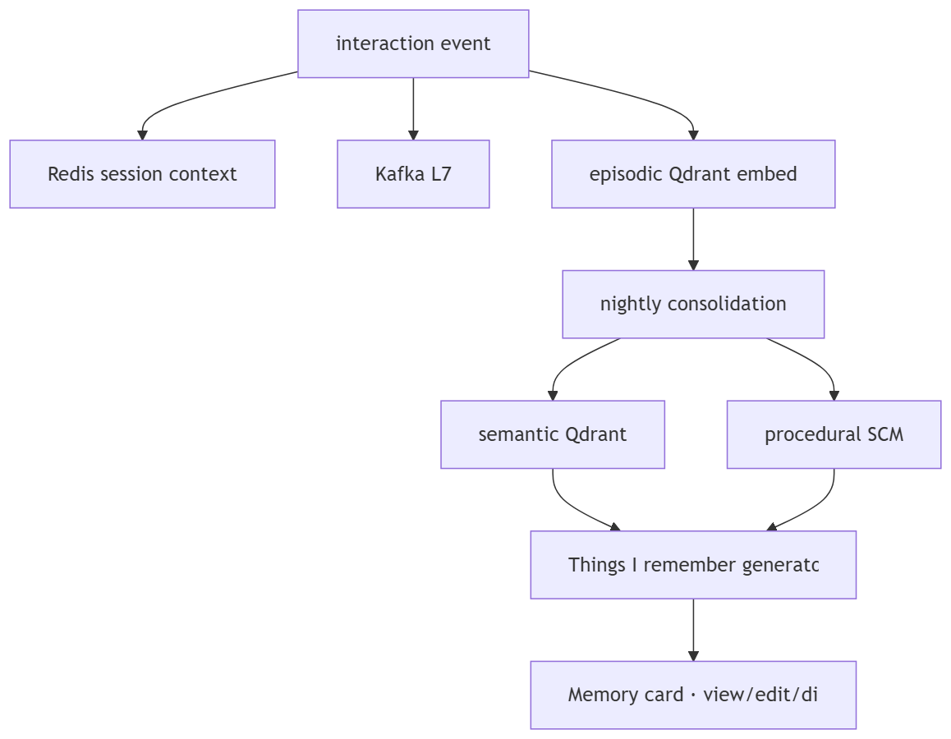

3. Spaced repetition
- SM-2 variant: quality≥3 → interval 1 → 6 → ×EF; EF init 2.5, floor 1.3;
incorrect → repetitions 0, interval 1 day.
- Ebbinghaus overlay: next_review = last_review + stability × e^(days_since);
stability personalized per concept per student from actual forget-rate data (KF2).
- Due queue drives Home "review" items and PRACTICE re-practice labels (Doc 15).

4. "Things I remember about you"
- Weekly, 3–5 pattern-based TRUE observations; never generic praise; never a bare 0.
- Onboarding-seeded facts labelled as such, not inferred weakness.
- Every item shows provenance + scope; user can view, edit, disable or delete it.
- Parent/teacher dashboards consume a READ-ONLY memory API (weekly digest:
mastered_this_week, gap_concepts, recommended_focus) under Doc 24 permissions.

OKF
KF1 90+ day persistence with no personalization degradation · KF2 SRS intervals from real
forget-rate data · KF3 parent report answers "what does my child not understand" ·
KF4 session context injected into every LLM call (no stateless turns) · KF5 memory query
≤50ms p95 via Redis hot path.

